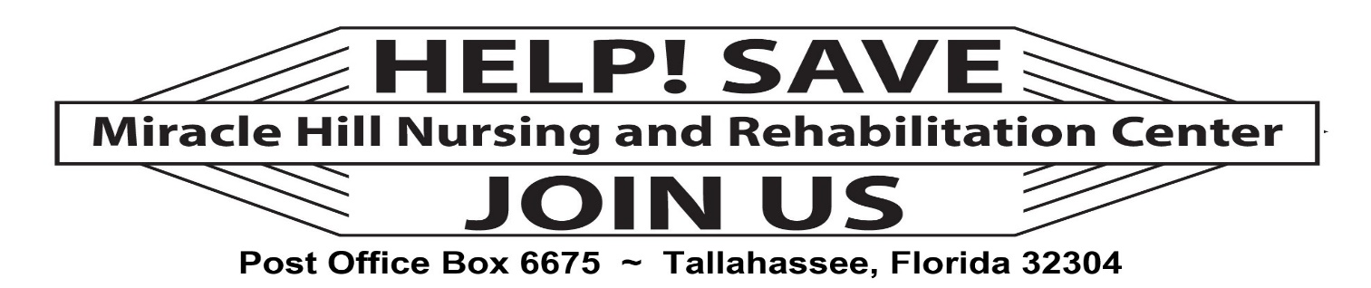

Post Office Box 6675 ~ Tallahassee, FL 32314

Donation Form - Date __________

Donor Information Donation $___________

Name _______________________________________ Check__ Cash __

Address _______________________________ _____________________________
City State Zip

Email _____________________________________ Telephone _____________________

Church ____________________________ ____________________________________
City State

Received by ____________________

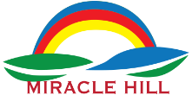

Miracle Hill Nursing and Rehabilitation Center, located at 1329 Abraham Street in Tallahassee, Florida, is a 120-bed skilled nursing and rehabilitative facility serving all persons needing long-term nursing care and/or rehabilitative services—regardless of race, color, sex, creed, national origin, or disability. Miracle Hill is owned and operated by the Florida State Primitive Baptist Convention, Inc. (FSPBC).

The “brain child” of FSPBC Fourth President Moses General Miles during his first term as president, 1962, the Convention members rallied and supported the establishment of Miracle Hill, which opened its doors to the first resident in September 1969.

Since then, Miracle Hill was considered among the top nursing homes in Florida—consistently receiving superior ratings for years. Unfortunately, during recent years (including COVID-19), Miracle Hill became victim to enormous debt and was slated to be sold to combat the debt.

Several long-time FSPBC members, community leaders, and family members who had been served by Miracle Hill did not support the idea of selling this “black, Convention-owned, community staple and formed a committee to “Save Miracle Hill.” With new Convention leadership and new Miracle Hill management, the sale was halted; however, the debt did not go away and the day-to-day operation requires the need for donations in order to get it back to its prominence and self-sufficient. Help!!!! Make check payable to: Miracle Hill.

